







+91 9313035076, +91 9537651265
info@bkexportsinternational.com www.bkexportsinternational.com
90, Jasodanagar Cross Road, Nr. Canal, Opp. Baroda Express Highway, Amraiwadi, Ahmedabad, Gujarat, India - 380026

DT: 18.08.2026

TO,

EXPORT INSPECTION AGENCY

AHMEDABAD.

DEAR SIR,
SUB: Retrospective CoO

We have apply Asian India Free Trade Agreement (AIFTA) IN Retrospective mode Because BL RECEVEID LATE FROM SHIPPING AGENT. SO PLEASE ISSUE CERTIFICATE.

REGARDS,

FOR B K EXPORTS.

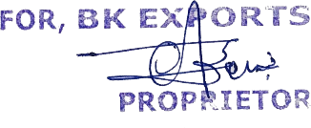

PROPRITOR

ALPESH JAIN

